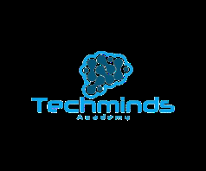

#### Techminds Academy: Empowering the Next Generation of Coders

#### Introduction: Welcome to techminds Academy where we`re passionate about empowering the next generation of coders and tech innovators. As a leading coding tech school , our mission is to provide high-quality education and training in programming, software development, and technology. In this document, we`ll outline the key benefits of Techminds Academy and provide you with the tools and resources you need to effectively market our programs to potential students. At Techminds Academy, we believe that technology is not just a tool but a catalyst for global transformation. Our vision is to build a community of innovators, problem-solvers, and leaders who will shape the digital future. We emphasize accessibility, affordability, and excellence in training. Techminds bridges the global demand for tech talent with hands-on, industry-relevant education.

#### Techminds Academy is a premier coding school dedicated to transforming aspiring tech professionals into skilled, job-ready experts. With a mission to make high-quality tech education accessible and affordable, we offer hands-on, career-focused programs in today’s most in-demand fields. Our supportive community, expert instructors, and robust job placement support set us apart as the go-to choice for students worldwide seeking to launch rewarding tech careers.



## This draft provides marketers with a comprehensive overview of our top programs—Web Design/Development, Data Science, Digital Marketing, Graphic Design, and Cybersecurity—along with key selling points to craft compelling campaigns that resonate with prospective students. Career Outlook: Web developers earn an average of $65,000 - $110,000 annually, with demand growing rapidly across industries. Sample Projects: E-commerce stores, personal portfolios, and interactive dashboards. Who is it for?: Ideal for creatives, career changers, and entrepreneurs who want to build their own platforms. Career Outlook: Data Scientists command salaries from $80,000 to $130,000+, with job growth projected at 36% this decade. Sample Projects: Predictive analytics for healthcare, AI-powered chatbots, and sales forecasting. Who is it for?: Best suited for analytical thinkers, problem-solvers, and professionals eager to upskill. Career Outlook: Digital marketers typically earn $50,000 - $95,000 annually. Demand is strong as businesses shift to digital-first strategies. Sample Projects: Real ad campaigns, SEO optimization projects, and social media growth plans. Who is it for?: Creative individuals, entrepreneurs, and communication enthusiasts. Career Outlook: Graphic designers earn between $45,000 - $85,000 annually. Skilled designers are in demand across tech, media, and advertising. Sample Projects: Brand identity kits, UI/UX app mockups, and social media graphics. Who is it for?: Aspiring creatives, freelancers, and professionals looking to strengthen their visual storytelling skills. Career Outlook: Cybersecurity specialists earn $85,000 - $150,000 annually, with global demand expected to surge by 33% by 2030. Sample Projects: Penetration testing, network vulnerability assessments, and simulated attack defenses. Who is it for?: Tech enthusiasts, IT professionals, and anyone passionate about digital safety.

#### Key Benefits: 1. Hands-on learning: Our programs focus on practical, hands-on experience, ensuring students gain the skills and confidence they need to succeed in the tech industry . 2. Industry_relevant curriculum: Our curriculum is designed in collaboration with industry experts, ensuring students learn the latest technologies and trends. 3. Experienced Instructors: Our instructors are experienced professional with a passion for teaching and mentoring. 4. Career support: We provide career support and guidance to help students achieve the career goals. Marketing Strategies

#### Social media: Utilize social media platforms to reach potential students students and promote our programs.

#### Influencer Partnership: Partner with influencers and industry thought leaders to promote our programs.

#### Content Marketing: Create engaging contents (blog posts, videos, etc.) to showcase our programs and expertise .

#### Networking Events: Attend networking events and conferences to connect with potential students and industry professionals.

#### Email Campaigns: Nurture leads with drip campaigns showcasing program benefits, alumni stories, and limited time discounts.

#### Visual Storytelling: use infographics to highlight tech job growth. Also showcase students project demos and portfolios to demonstrate tangible outcomes.

#### Testimonials and case Studies: share engaging stories about tech related events like John Doe a former primary school teacher became a Data scientist and changed his life for good. Also create video testimonials featuring diverse students to appeal to broad audience.

#### Urgency and Incentives: Offer early birds discounts or limited-time enrollment bonuses to drive conversions and also emphasize job placement guarantees etc.

#### Flexible Learning: Online , part-time, and full time options cater to diverse schedule, making tech education accesible to all.

#### Industry-Recognized Certifications: Our certificates are valued by employers worldwide, giving our graduates a competitive edge.

#### Sales Strategy: Below are the strategies you can use to market us better

#### Identify target audience: Identify potential students who are interested in coding and tech education.

#### Build Relationship: Build Relationship with potential students and provide them with personalized support and guidance.

#### Highlight Benefits: highlight the benefits of Techminds Academy, including our hands-on learning approach, industry-relevant curriculum, and career support.

## Key Programs at TechMinds Academy Each program at TechMinds Academy has been carefully designed with input from industry experts and real-world employers. We don’t just teach theory — we equip our students with the ability to build, create, and innovate. Below, you’ll find a deeper dive into our flagship programs, including career outlook, sample projects, and who each program is best suited for.



### 1. Web Design/Development Career Outlook: Web developers earn an average of $65,000 - $110,000 annually, with demand growing rapidly across industries. Sample Projects: E-commerce stores, personal portfolios, and interactive dashboards. Who is it for?: Ideal for creatives, career changers, and entrepreneurs who want to build their own platforms.



**Program Overview**:  
Our Web Design/Development career track is a comprehensive program designed to equip students with the skills to create responsive, user-friendly websites and robust web applications. This course combines front-end and back-end development, covering modern technologies and frameworks to prepare students for roles such as Full Stack Developer, Front-End Developer, or Web Designer.  
  
Career Outlook: Web developers earn an average of $65,000 - $110,000 annually, with demand growing rapidly across industries.  
Sample Projects: E-commerce stores, personal portfolios, and interactive dashboards.  
Who is it for?: Ideal for creatives, career changers, and entrepreneurs who want to build their own platforms.

**Key Features**:

**Curriculum**: Learn HTML, CSS, JavaScript, React, Node.js, and databases like MongoDB. Students also master responsive design, UI/UX principles, and content management systems like WordPress.

**Hands-On Learning**: Build real-world projects, including e-commerce platforms and interactive portfolios, to showcase skills to employers.

**Duration**: 3 months (full-time) or 6 months (part-time, online).

**Career Support**: Includes resume building, mock interviews, and connections to over 300 partner companies for job placement.

**Certifications**: Earn a professional certificate recognized by employers worldwide.

**Why Market This Program?**

High demand for web developers in industries ranging from startups to global corporations.

Appeals to creative individuals passionate about design and problem-solvers who enjoy coding.

Flexible learning options cater to busy professionals and career changers.

Highlight success stories: “Our graduates have landed roles at top tech firms, thanks to our practical training and industry connections!”

**Marketing Angle**:  
Position this program as the gateway to a creative and lucrative career in web development. Use testimonials from alumni who’ve transitioned into high-paying roles. Emphasize the program’s blend of design and technical skills, perfect for those who want to “build the internet of tomorrow.”

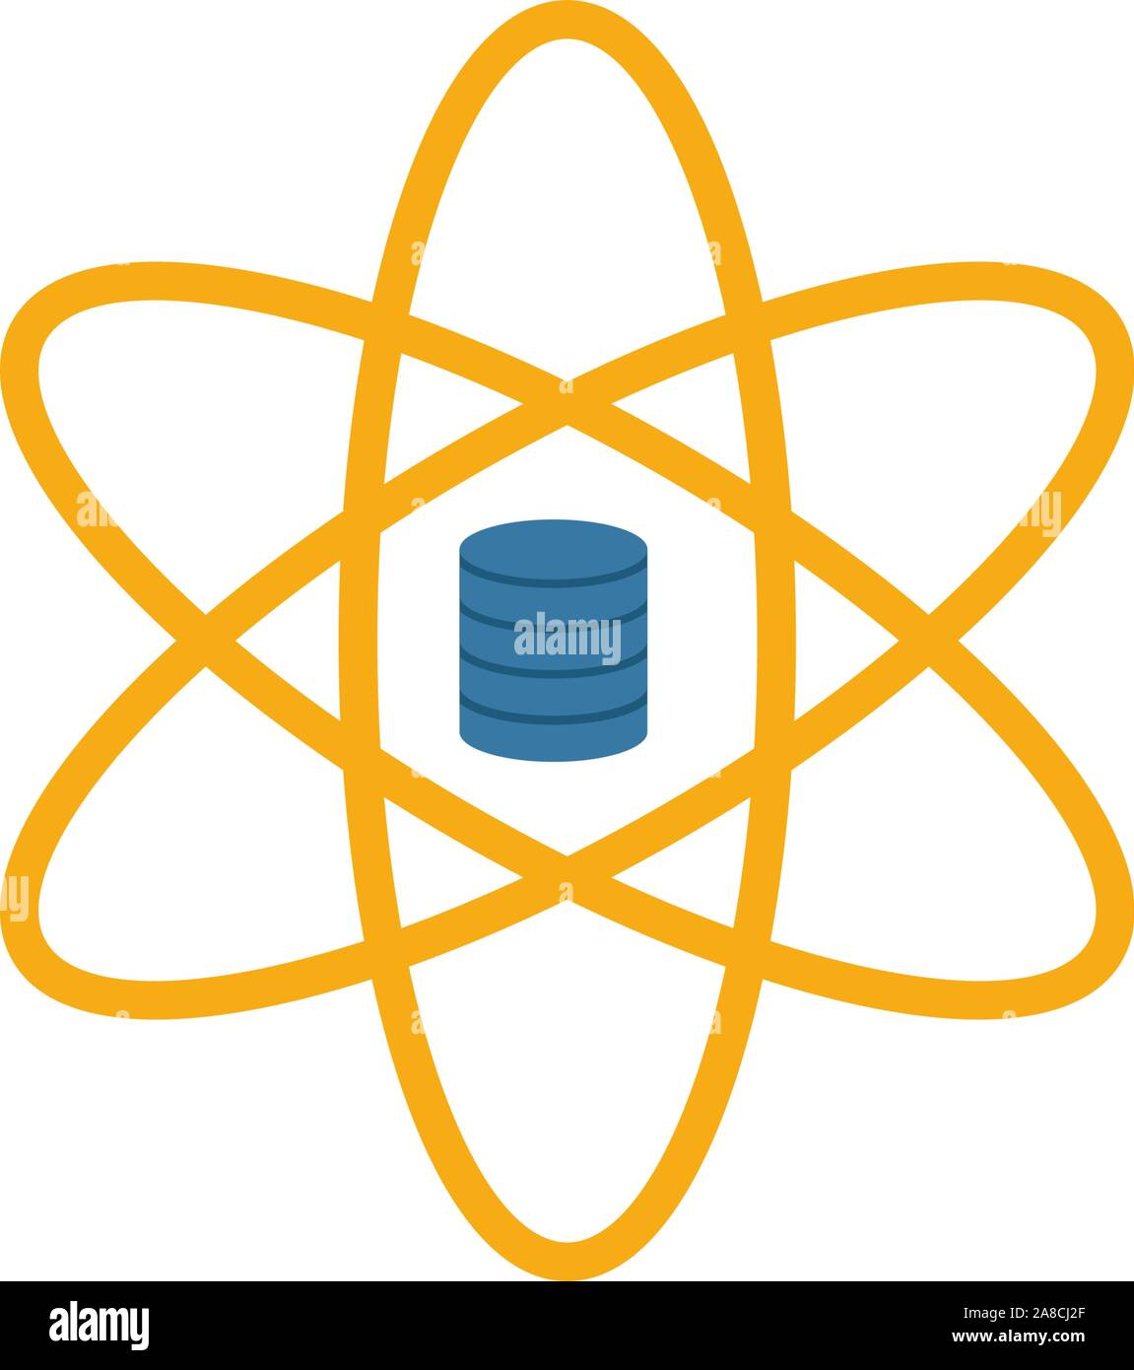

### 2. Data Science Career Outlook: Data Scientists command salaries from $80,000 to $130,000+, with job growth projected at 36% this decade. Sample Projects: Predictive analytics for healthcare, AI-powered chatbots, and sales forecasting. Who is it for?: Best suited for analytical thinkers, problem-solvers, and professionals eager to upskill.



**Program Overview**:  
The Data Science career track is tailored for those eager to harness the power of data to drive business decisions. This program covers data analysis, machine learning, and visualization, preparing students for roles like Data Scientist, Data Analyst, or Machine Learning Engineer.  
  
Career Outlook: Data Scientists command salaries from $80,000 to $130,000+, with job growth projected at 36% this decade.  
Sample Projects: Predictive analytics for healthcare, AI-powered chatbots, and sales forecasting.  
Who is it for?: Best suited for analytical thinkers, problem-solvers, and professionals eager to upskill.

**Key Features**:

**Curriculum**: Master Python, SQL, Pandas, TensorFlow, and data visualization tools like Tableau. Learn to analyze large datasets, build predictive models, and create actionable insights.

**Hands-On Learning**: Work on real-world projects, such as predictive analytics for retail or healthcare, to build a professional portfolio.

**Duration**: 5 months for full stack( 2 months for frontend)

**Career Support**: Dedicated career coaching, including resume optimization, mock interviews, and job placement assistance with leading companies.



**Certifications**: Globally recognized Data Science certificate.  
  
Career Outlook: Data Scientists command salaries from $80,000 to $130,000+, with job growth projected at 36% this decade.  
Sample Projects: Predictive analytics for healthcare, AI-powered chatbots, and sales forecasting.  
Who is it for?: Best suited for analytical thinkers, problem-solvers, and professionals eager to upskill.

**Why Market This Program?**

Data science is a top-paying field with a growing demand across industries like finance, healthcare, and tech.

Appeals to analytical minds who enjoy solving complex problems with data.

Our program stands out with its focus on practical, project-based learning and job placement support.

Highlight affordability: “High-quality training at a fraction of the cost of traditional programs.”

**Marketing Angle**:  
Promote this program as the key to unlocking high-paying, impactful careers in data-driven industries. Use data-driven visuals (e.g., infographics showing salary trends for data scientists) and success stories like, “From beginner to Data Scientist at a Fortune 500 company in just 20 weeks!” Target professionals looking to upskill or pivot into a future-proof career.

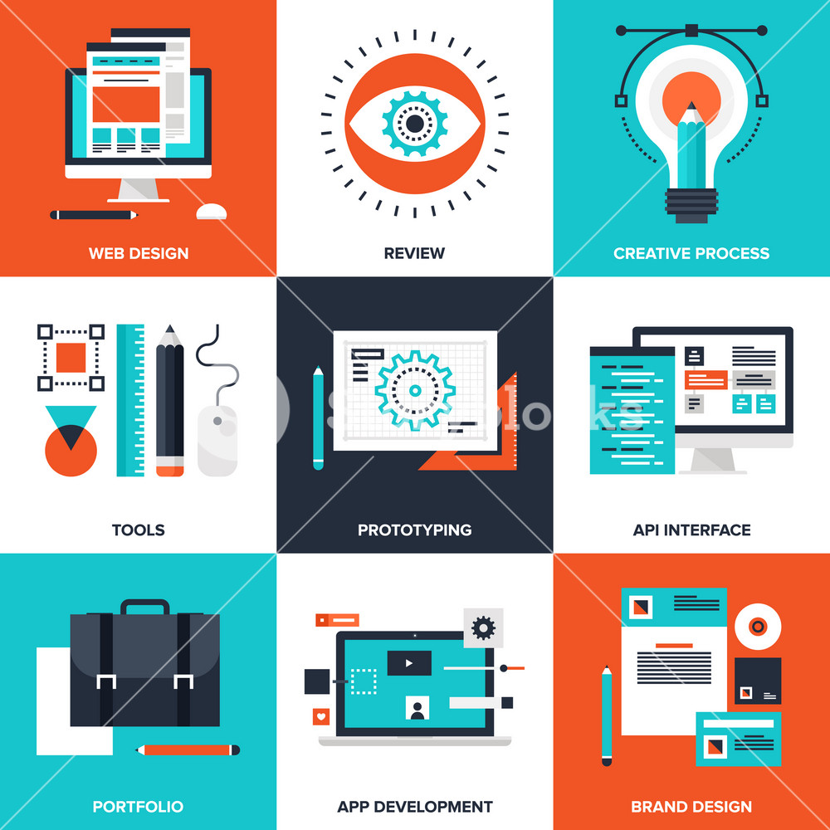

### 3. Digital Marketing Career Outlook: Digital marketers typically earn $50,000 - $95,000 annually. Demand is strong as businesses shift to digital-first strategies. Sample Projects: Real ad campaigns, SEO optimization projects, and social media growth plans. Who is it for?: Creative individuals, entrepreneurs, and communication enthusiasts.



**Program Overview**:  
Our Digital Marketing program empowers students to master the art and science of online promotion, preparing them for roles like Digital Marketing Specialist, SEO Analyst, or Social Media Manager. This course covers strategies to boost brand visibility and drive conversions in a digital-first world.  
  
Career Outlook: Digital marketers typically earn $50,000 - $95,000 annually. Demand is strong as businesses shift to digital-first strategies.  
Sample Projects: Real ad campaigns, SEO optimization projects, and social media growth plans.  
Who is it for?: Creative individuals, entrepreneurs, and communication enthusiasts.

**Key Features**:

**Curriculum**: Learn SEO, social media marketing, content creation, Google Ads, and analytics tools like Google Analytics. Understand consumer behavior and campaign optimization.

**Hands-On Learning**: Create real marketing campaigns, optimize websites for search engines, and analyze performance metrics.

**Duration**: 12 weeks (full-time) or 24 weeks (part-time, online).

**Career Support**: Resume building, interview prep, and access to exclusive job opportunities with partner companies.



**Certifications**: Earn a Digital Marketing certificate recognized by industry leaders.  
  
Career Outlook: Digital marketers typically earn $50,000 - $95,000 annually. Demand is strong as businesses shift to digital-first strategies.  
Sample Projects: Real ad campaigns, SEO optimization projects, and social media growth plans.  
Who is it for?: Creative individuals, entrepreneurs, and communication enthusiasts.

**Why Market This Program?**

Digital marketing is essential for businesses of all sizes, ensuring high employability.

Appeals to creative and strategic thinkers who want to influence online audiences.

Short duration makes it ideal for quick career transitions.

Highlight the program’s focus on measurable results: “Learn to drive traffic and boost sales with cutting-edge strategies.”

**Marketing Angle**:  
Position this program as the perfect blend of creativity and analytics for those who want to shape the digital landscape. Use vibrant visuals of social media campaigns and SEO dashboards. Share testimonials like, “I launched a successful freelance marketing business after TechMinds Academy!” Target young professionals and entrepreneurs looking to thrive in the digital economy.



### 4. Graphic Design Career Outlook: Graphic designers earn between $45,000 - $85,000 annually. Skilled designers are in demand across tech, media, and advertising. Sample Projects: Brand identity kits, UI/UX app mockups, and social media graphics. Who is it for?: Aspiring creatives, freelancers, and professionals looking to strengthen their visual storytelling skills.



**Program Overview**:  
The Graphic Design program equips students with the skills to create visually stunning designs for digital and print media. Ideal for aspiring Graphic Designers, UI/UX Designers, or Creative Directors, this course blends creativity with technical expertise.  
  
Career Outlook: Graphic designers earn between $45,000 - $85,000 annually. Skilled designers are in demand across tech, media, and advertising.  
Sample Projects: Brand identity kits, UI/UX app mockups, and social media graphics.  
Who is it for?: Aspiring creatives, freelancers, and professionals looking to strengthen their visual storytelling skills.

**Key Features**:

**Curriculum**: Master Adobe Creative Suite (Photoshop, Illustrator, InDesign), typography, branding, and UI/UX design principles. Learn to create logos, web graphics, and marketing collateral.

**Hands-On Learning**: Build a professional portfolio with projects like brand identity designs and website mockups.

**Duration**: 14 weeks (full-time) or 28 weeks (part-time, online).

**Career Support**: Personalized career coaching and connections to creative agencies and tech firms.



**Certifications**: Industry-recognized Graphic Design certificate.  
  
Career Outlook: Graphic designers earn between $45,000 - $85,000 annually. Skilled designers are in demand across tech, media, and advertising.  
Sample Projects: Brand identity kits, UI/UX app mockups, and social media graphics.  
Who is it for?: Aspiring creatives, freelancers, and professionals looking to strengthen their visual storytelling skills.

**Why Market This Program?**

High demand for graphic designers in advertising, tech, and media industries.

Appeals to creative individuals who want to turn their passion into a career.

Portfolio-driven training ensures students have tangible work to showcase to employers.

Highlight flexibility: “Learn from anywhere, at your own pace, with expert guidance.”

**Marketing Angle**:  
Promote this program as the launchpad for creative careers, emphasizing the ability to “turn ideas into stunning visuals.” Use eye-catching design samples from student portfolios in marketing materials. Share success stories like, “From hobbyist to professional designer at a top agency in just 14 weeks!” Target artists and creatives seeking to monetize their skills.



### 5. Cybersecurity Career Outlook: Cybersecurity specialists earn $85,000 - $150,000 annually, with global demand expected to surge by 33% by 2030. Sample Projects: Penetration testing, network vulnerability assessments, and simulated attack defenses. Who is it for?: Tech enthusiasts, IT professionals, and anyone passionate about digital safety.



**Program Overview**:  
Our Cybersecurity program prepares students to protect organizations from digital threats, equipping them for roles like Cybersecurity Analyst, Penetration Tester, or IT Security Specialist. This course covers the latest tools and techniques to safeguard digital assets in a rapidly evolving threat landscape.  
  
Career Outlook: Cybersecurity specialists earn $85,000 - $150,000 annually, with global demand expected to surge by 33% by 2030.  
Sample Projects: Penetration testing, network vulnerability assessments, and simulated attack defenses.  
Who is it for?: Tech enthusiasts, IT professionals, and anyone passionate about digital safety.

**Key Features**:

**Curriculum**: Learn ethical hacking, network security, cryptography, and threat analysis. Master tools like Wireshark, Metasploit, and CompTIA Security+ prep.

**Hands-On Learning**: Simulate real-world cyber attacks and defenses in virtual labs, building practical skills.

**Duration**: 4 months (full-time) or 5 months (part-time, online).

**Career Support**: Resume building, mock interviews, and job placement with top cybersecurity firms.



**Certifications**: Earn a Cybersecurity certificate and prep for CompTIA Security+ certification.  
  
Career Outlook: Cybersecurity specialists earn $85,000 - $150,000 annually, with global demand expected to surge by 33% by 2030.  
Sample Projects: Penetration testing, network vulnerability assessments, and simulated attack defenses.  
Who is it for?: Tech enthusiasts, IT professionals, and anyone passionate about digital safety.

**Why Market This Program?**



Cybersecurity is a critical, high-paying field with a global shortage of skilled professionals.  
  
Career Outlook: Cybersecurity specialists earn $85,000 - $150,000 annually, with global demand expected to surge by 33% by 2030.  
Sample Projects: Penetration testing, network vulnerability assessments, and simulated attack defenses.  
Who is it for?: Tech enthusiasts, IT professionals, and anyone passionate about digital safety.

Appeals to tech-savvy individuals passionate about protecting digital infrastructure.

Hands-on labs and industry-recognized certifications boost employability.

Highlight urgency: “Be the hero businesses need in the fight against cybercrime.”



**Marketing Angle**:  
 Position this program as the path to a high-stakes, high-reward career in cybersecurity. Use bold visuals of digital locks and hacker-themed graphics. Share stats like, “Cybersecurity jobs are projected to grow 33% by 2030!” and testimonials like, “TechMinds Academy gave me the skills to land a cybersecurity role at a Fortune 500 company.” Target tech enthusiasts and career changers looking for impact.  
  
Career Outlook: Cybersecurity specialists earn $85,000 - $150,000 annually, with global demand expected to surge by 33% by 2030.  
Sample Projects: Penetration testing, network vulnerability assessments, and simulated attack defenses.  
Who is it for?: Tech enthusiasts, IT professionals, and anyone passionate about digital safety.

## Call to Action:

#### TechMinds Academy is your partner in empowering students to achieve their tech dreams. Leverage this draft to craft compelling campaigns that highlight our affordable, hands-on programs and unbeatable career support. Let’s inspire the next generation of tech innovators together!

#### Conclusions: Looking ahead, Techminds Academy is committed to evolving alongside technology itself. From Artificial Intelligence and Cloud Computing to Blockchain and Emerging Digital Trends, our curriculum will continue to expand, ensuring students remain at the cutting edge. We invite you to not only learn with us but to join a global movement of innovation and opportunity.

#### Techminds Academy is committed to providing high-quality education and training in programming, software development, and technology . With our experienced instructors , industry-relevant curriculum, and career support , we`re confident that our students will succeed in tech industry. We look forward to working with you to promote our programs and empower the next generation of coders .

#### 